**Sprint 1- Endurance Design Document**

**November 7, 2023**

**Authored by: Christopher Buzaid, Zacahry Zucconi, Royce Amburg**

**Table of Contents**

**1. Executive Summary…………………………………………………… 3**

1.1 Project Overview …………………………………………………………… 3

1.2 Purpose and Scope of this Specification ……………………………………. 3

**2. Product/ Service Description…………………………………………. 4**

2.1 Product Context……………………………………………………………... 4

2.2 User Characteristics…………………………………………………………. 4

2.3 Assumptions………………………………………………………………… 4

2.4 Constraints…………………………………………………………………... 4

2.5 Dependencies………………………………………………………………... 5

**3. REQUIREMENTS……………………………………………………. 5**

3.1 Functional Requirements……………………………………………………. 5

3.2 Security……………………………………………………………………… 7

3.2.1 Protection………………………………………………………………….. 7

3.2.2 Authorization and Authentication…………………………………………. 7

3.3 Portability……………………………………………………………………. 7

**4. Requirements Confirmation/Stakeholder Sign-Off……………….. 7**

**5. SYSTEM DESIGN…………………………………………………… 7**

5.1 Algorithm……………………………………………………………………. 7

5.2 System Flow………………………………………………………………… 8

5.3 Software……………………………………………………………………... 8

5.4 Hardware…………………………………………………………………….. 9

5.5 Test Plan……………………………………………………………………..9

5.6 Task List/Gantt Chart………………………………………………………..11

5.7 Staffing Plan…………………………………………………………………11

**1. Executive Summary**

**1.1 Project Overview**

* The Sprint 1 Endurance project is one part of a three part project that aims to develop and code a Sphero Bolt robot to successfully complete multiple sprint courses in our classroom, HH 208. The first Sprint, Endurance, aims to complete one course that travels around the periphery of our classroom. The robot will begin from a designated starting point, and it should demonstrate specific behaviors, including emitting certain colored lights and should speak at the beginning and end of the sprint. This project is suitable for educational purposes, STEM programs, and robotic enthusiasts.

**1.2 Purpose and Scope of this Specification**

The purpose of this specification is to describe our groups completion of the first sprint, Endurance, in our robotics project, including our requirements, code, constraints and overall success of our first Sprint . The intended audience of this program is Dr. Eckert, and the other groups to compare how our robots made it across the course.

**In scope:**

* The group will build a fully functional robot that is able to travel around the periphery of room HH 208 and speak.
* All group members will work on this document and the code for Sprint 1- Endurance. The date of completion will be before 11/7/23, at 11:59 PM

**Out of scope:**

* We should be able to finish Sprint 2: Accuracy, by 11/16/23 at 11:59 PM, possibly even before
* The group will build a fully functional robot program to perform a “figure 8 course” by the due date of Sprint 2: Accuracy.
* Sprint 3 can not be completed at the time being, and therefore is out of scope:
* Sprint 3: Agility (November 30th, 2023 at 11:59 PM)
* The group will build a fully functional robot program to avoid 3 obstacles on an obstacle course through the classroom by the due date of Sprint 3: Agility.
* Presentation on robot code and triathlon (December 5th, 2023 1:00 PM)

**2. Product/ Service Description**

The product is a sphere that is able to roll and spin in any direction that is controlled via user input from block code in the Sphero Edu application. Its environment that the robot is in, is a classroom with blue tape on the ground to mark its path with obstacles like desks and chairs making the margin for error slim. The robot can “talk” through the speakers of a computer and it moves using a motor that shifts its weight towards a specific direction. The robot even emits colored lights that can be changed using the block code.

**2.1 Product Context**

This product relates to the famous automobiles we all drive. They both require user input in order to move. The robot is unable to move on its own, and requires the user to input, block code, in order for it to move. This is much like how a car can not drive itself, and require the user (aka. the driver) to start the engine using a key, use the gas pedals, and steering wheel, in order to make it move.

**2.2 User Characteristics**

* Users of this project may include students, educators, and robotics enthusiasts with varying levels of experience and technical expertise. Participants are expected to possess basic programming knowledge and be able to control the robot using compatible devices.
  + Student- Possess a basic understanding of programming concepts and robotics. Are actively interested in studying computer science or robotics and are eager to learn more of the subject.
  + Educator- A teacher or professor in the field of computer science or robotics who fully understands robotics and has years of experience in the field and will use the product as a tool for teaching their students.
  + Robotics Enthusiasts- Passionate about robotics and have a varying range of experience levels that may come from DIY robotic projects.

**2.3 Assumptions**

The equipment is not always available due to only one of us having access to the robot. We also all have different schedules making it challenging to find times to work together on the project. User expertise is a factor as well due to some of us having more background experience with coding than others. The Sphero operating system is constantly available as it is a program on our devices,however the Sphero robot itself is not constantly available.

**2.4 Constraints**

* Room Availability - HH room 208 isn't always available as classes and lectures occur there multiple times every day. The group must find windows throughout the day to go to the room.
* Classmates Availability - The group must find windows throughout the day to meet to work on the project that best works with everyone's schedule.
* System constraints could include a device such as a laptop not having access to download the Sphero Edu application.
* The use of block code may be a constraint as some members may not have experience in the use of block coding.

**2.5 Dependencies**

* Having the programed functional robot is a dependency
* The course needs to be set up before we can execute the requirements. (Yellow Square, Blue tape, Obstacles etc)
* In order to connect to the robot you must download the Sphero Edu application onto your device.

**3. Requirements**

***3.1 Functional Requirements***

| **Req#** | **Requirement** | **Comments** | **Priority** | **Date Reviewed** | **SME Reviewed / Approved** |
| --- | --- | --- | --- | --- | --- |
| **ENDUR_01** | System must successfully travel around the periphery of room HH208. | This is a “Must have” as the Sphero robot must complete the Endurance course entirely. | 1 | 11/3/2023 | 11/6/2023  Approved |
| **ENDUR_02** | The system must start from the yellow square with blue tape. | The yellow square and blue tape indicate where the course begins, place it here, aim, and watch it go, making sure the robot goes in a straight path on the blue tape | 1 | 11/3/2023 | 11/6/2023  Approved |
| **ENDUR_03** | System must turn green and speak “Ready, Set, Go” at the beginning of course. | Signifies that the test is about to begin, and adds a bit of character to the robot, instead of just having it start, also give time to start recording video | 1 | 11/3/2023 | 11/6/2023  Approved |
| **ENDUR_04** | System must return to its starting location | This is the final piece of the puzzle, where the after the robot has successfully made three turns, must make it back to start and stop, to be a successful run | 1 | 11/3/2023 | 11/6/2023  Approved |
| **ENDUR_05** | System must turn red and say “I’m done and I need water” at the end of course. | This signifies that the test is complete, and again, adds more character to the robot | 1 | 11/3/2023 | 11/6/2023  Approved |
| **ENDUR_06** | System must complete course without colliding with any objects | This is one of the most important aspects, as the Sphero must flawlessly make it across the course, or it could be a failure | 1 | 11/3/2023 | 11/6/2023  Approved |
| **ENDUR_07** | System must make it to the end of the line and turn 3 different times | The turns can be off a little, but it can’t be too off. As long as it stays fairly on course, and turns in the correct direction, it’s a success | 1 | 11/3/2023 | 11/6/2023  Approved |
| **ENDUR_08** | System must have representative sensor data after the completion of the endurance course | Must be completed to show the pathway of the robot. | 1 | 11/3/2023 | 11/7/2023  Approved |

***3.2 Security***

**3.2.1 Protection**

* Only one person has access to the robot at a time as the robot can only connect to one device/system at a time.
* The robot has a unique name that allows easy connection and helps prevent a user from connecting to another group's robot.
* A user cannot gain access to the robot if they do not have the authorized credentials, i.e. not a group member working on the project
* A user does not have the ability to view or modify the robots source code
* The robot does not have the ability to run without an authorized users connection to the robot via the Sphero Edu application

**3.2.2 Authorization and Authentication**

* The Robot will request the user to verify who they are by providing the correct credentials forcing them to authenticate themselves to the system.
* An Administrative user is able to grant users with specific permissions to the robot. Internal users will have access to make modifications to the robot. End users will have access to connect to the robot and run the system
* When a user authenticates themselves successfully we will ask for the users email or phone number and store their device information. When a preexisting user authenticates to the system, we give them the ability to sign in with a one time passcode instead of their username and password.

**3.3 Portability**

The Sphero robot has high portability potential. The robot itself is very small, able to fit in your hand and comes in a carrying case that has the ability to hold the robot and the charger. It is also very easy to obtain access to the Sphero Edu as it can be downloaded off of the Sphero website onto a smartphone, laptop, and pretty much any device, as long as the device has bluetooth capabilities. You can run it with many OS systems, such as Windows, and Apple, so the type of device you are using does not matter.

**4.**

| **Meeting Date** | **Attendees (name and role)** | **Comments** |
| --- | --- | --- |
| **11/6/2023** | **Chris Buzaid(Block code, System Design Document) Zachary Zucconi (System Design Document)** | **Confirmed all except ENDUR_04** |
| **11/6/2023** | **Chris Buzaid(Block code, System Design Document)** | **Confirmed all except ENDUR_08** |
| **11/7/2023** | **Chris Buzaid(Block code, System Design Document) Zachary Zucconi (System Design Document) Royce Amburg** | **Confirmed all** |

**5. System Design**

**5.1 Algorithm**

Step 1: Place robot at starting location: Yellow tile with blue tape

Step 2: Aim robot so that it goes in a straight line from starting location

Step 3: Use block code so that the robot emits a green light

Step 4: Use block code so that robot speaks “Ready, Set, Go”

Step 5: Use block code to move robot forward

Step 6: Use block code to turn robot 90° at the end of the line

Step 7: Repeat steps 5 & 6 two more times

Step 8: Have robot stop at the starting location: Yellow tile with blue tape

Step 9: Use block code so that the robot emits a red light

Step 10: Use block code to have robot speak “I’m done and I need water”

**5.2 System Flow**

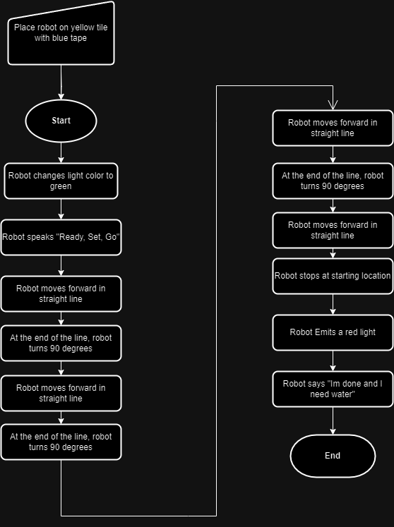

**5.3 Software**

* The software used to code the Sphero Robot was block code that was constructed in the Sphero Edu application.

**Code and sensor data is pictured below**

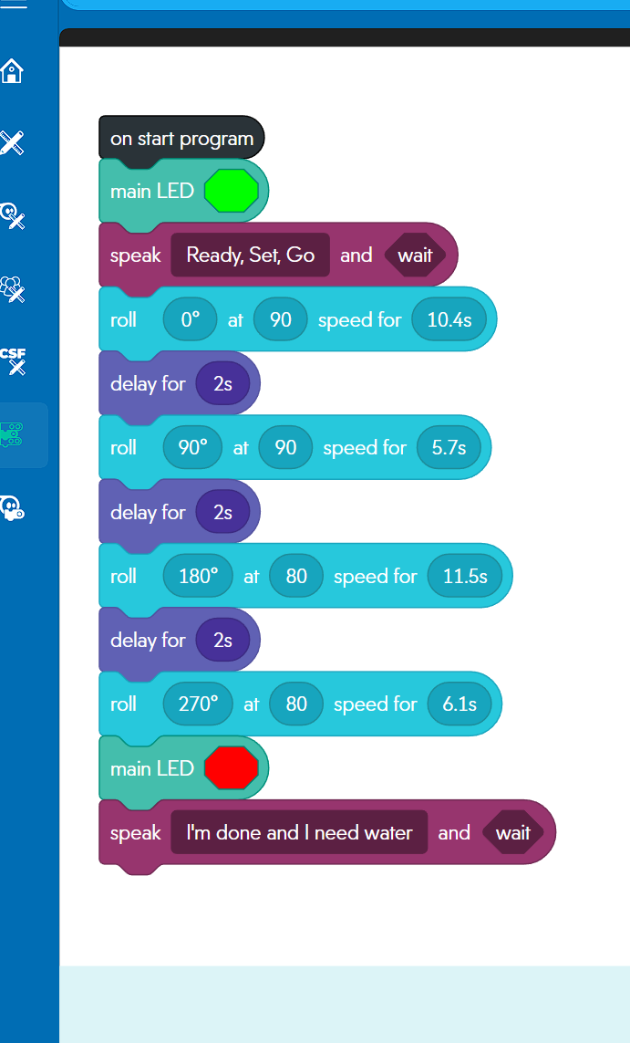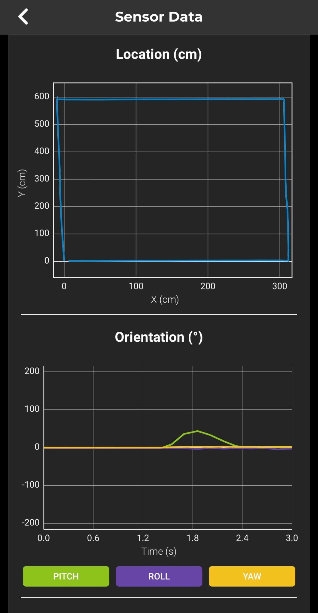

**5.4 Hardware**

* Sphero Edu application on a Windows Lenovo laptop, to develop, build, and test the code.
* An Apple Iphone was used to record the video and also to analyze the sensor data provided by the Sphero robot.

## **5.5 Test Plan**

| Reason for Test Case | Test Date | Expected Output | Observed Output | Staff Name | Pass/Fail |
| --- | --- | --- | --- | --- | --- |
| To make the robot move from the yellow tile with blue tape, to the end of line 1 | 11/6/23 | The robot would move to the end of the first corner and stop | The robot was a little off the line and went over | Zachary Zucconi | Fail |
| To make the robot move from the yellow tile with blue tape, to the end of line 1 | 11/6/23 | The robot would move to the end of the first corner and stop | The robot went off slightly again and went over, but was closer than previous test | Zachary Zucconi | Fail |
| To make the robot move from the yellow tile with blue tape, to the end of line 1 | 11/6/23 | The robot would move to the end of the first corner and stop | The robot successfully made it to the end of the first line starting from the yellow tile with blue tape | Zachary  Zucconi | Pass |
| To make the robot turn and move from the end of line 1 to the end of line 2 | 11/6/23 | The robot would successfully turn and move to the end of line 2 | The Sphero robot successfully turned but went a little to far from the end of line 2 | Chris  Buzaid | Fail |
| To make the robot turn and move from the end of line 1 to the end of line 2 | 11/6/23 | The robot would successfully turn and move to the end of line 2 | The Sphero robot successfully turned but was too short from the end of line 2 | Chris Buzaid | Fail |
| To make the robot turn and move from the end of line 1 to the end of line 2 | 11/6/23 | The robot would successfully turn and move to the end of line 2 | The Sphero robot successfully turned and successfully stopped at the end of line 2 | Chris Buzaid | Pass |
| To make the robot turn and move from the end of line 2 to the end of line 3 | 11/6/23 | The robot would successfully turn and move to the end of line 3 | The Sphero robot successfully turned and successfully moved to the end of line 3. | Chris Buzaid | Pass |
| To make the robot turn and move from line 3 to the end of line 4 and stop in the yellow starting tile | 11/6/23 | The robot would successfully turn and move from the end of line 3 to the end of line 4 and stop in the yellow tile | The robot was on course, but it went over the yellow tile by a few inches | Chris Buzaid | Fail |
| To make the robot turn and move from line 3 to the end of line 4 and stop in the yellow starting tile | 11/6/23 | The robot would successfully turn and move from the end of line 3 to the end of line 4 and stop in the yellow tile | The robot went to the left of the Yellow tile and was a short of the end of line 4 | Chris Buzaid | Fail |
| To make the robot turn and move from line 3 to the end of line 4 and stop in the yellow starting tile | 11/6/23 | The robot would successfully turn and move from the end of line 3 to the end of line 4 and stop in the yellow tile | The robot was on course and made it to the end of line 4 and stopped in the yellow tile | Chris Buzaid | Pass |

**5.6 Task list/Gantt Chart**

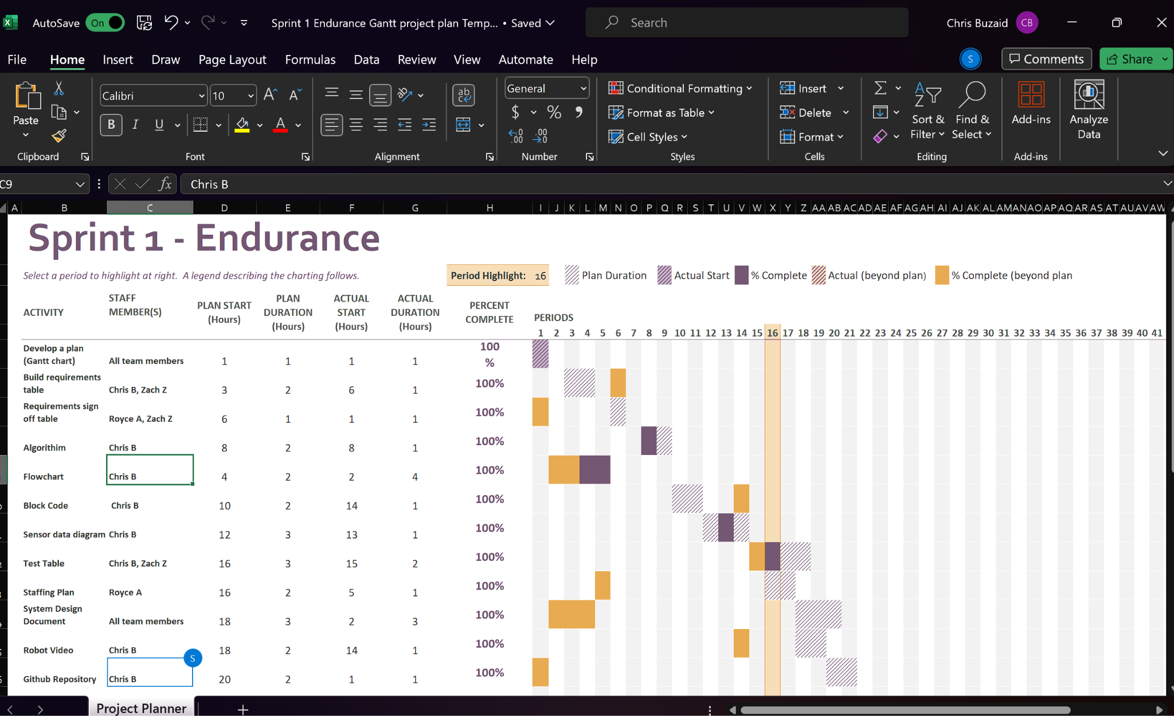

**5.7 Staffing Plan**

| Name | Role | Responsibility | Reports To |
| --- | --- | --- | --- |
| Zachary Zucconi | Assistant | Fill out sections embedded in System Design Document: Test Table, Requirements table etc. | Chris Buzaid |
| Chris Buzaid | Manager | Write the Block Code for robot and sensor data diagram.  Fill out sections embedded in the System Design Document, Test Table, Requirements table, etc. | Chris Buzaid |
| Royce Amburg | Assistant | Fill out sections in System Design document: Endurance Design etc. | Chris Buzaid |